Solutions to Risk Analysis Assignment 2

1. Mean of log stock returns of the companies.

|  |  |  |
| --- | --- | --- |
| Company | mean_log_return (mlr) | round(mlr) |
| MSFT | 0.000796584 | 8.00E-04 |
| APPL | 0.001013657 | 1.00E-03 |
| KO | 0.000223627 | 2.00E-04 |
| INTC | 0.00033289 | 3.00E-04 |
| WMT | 0.000345566 | 3.00E-04 |

All the companies are growing as mean value is positive for the given period of time and apparently Apple is growing faster as it has the highest mean value.

1. Standard deviation of log stock returns of the companies.

|  |  |  |
| --- | --- | --- |
| Company | sd_log_return (mlr) | round(mlr) |
| MSFT | 0.01577966 | 0.0158 |
| APPL | 0.01772833 | 0.0177 |
| KO | 0.01097888 | 0.011 |
| INTC | 0.01803018 | 0.018 |
| WMT | 0.01180310 | 0.0118 |

1. Data Frame for all companies with their mean and standard deviation.

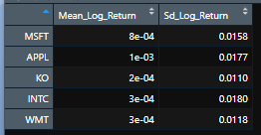 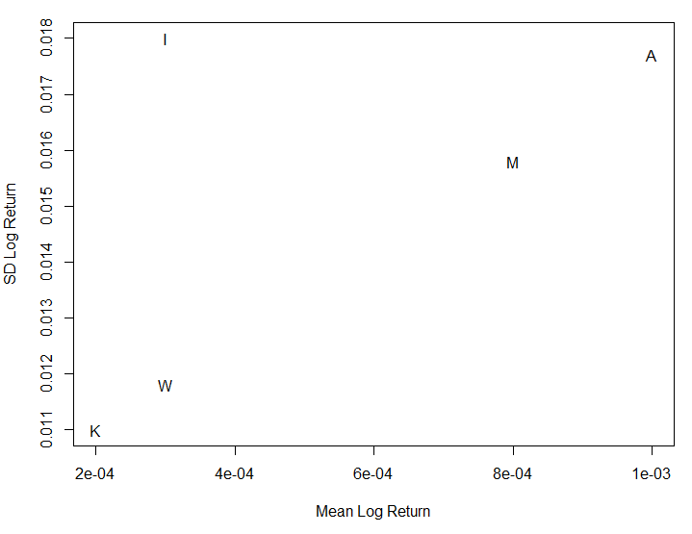

AAPL shows the highest mean log return among the stocks and comparatively high standard deviation of the return. INTC having moderate return shows the highest deviation. KO deviates the less and its mean return is also the lowest.

Generally, adding high return stock to the portfolio increases its variance and overall risk and vice versa (i.e. higher risk, higher reward). The choice of stocks depends on risk aversion degree.

1. Chart Series for the year 2020.
   1. Microsoft

*Microsoft Chart Series showing the Bollinger Band chart and Volume Traded during 2020*

At the year's onset, Microsoft trending was going up in steady and low volatility. By studying the candlesticks chart and comparing it to the Bollinger band during the end of January, one could consider the stock overbought. The candlesticks were crossing above the upper band, creating a "sell zone."

The price began to adjust right before the pandemic period accrued at the beginning of March. The pandemic impact was only during March, and the price started to recover again. Before the end of March, the candlesticks crossed the lower Bollinger band creating a "buy zone."

Since then, Microsoft's share price has been a steady up-trend with low volatility, which we can see by noticing the Bollinger bands narrow down.

After August, the Bollinger bands started to widen again, indicating prices more volatile, but it was not a clear signal to enter or exit the market.

* 1. Apple

*Apple Chart Series showing the Bollinger Band chart and Volume Traded during 2020*

In similarity with the general market, Apple's share price started the year steadily and trending up with low volatility. At the beginning of March, the pandemic began to affect the market and created a "buy zone" by noticing the candlesticks crossing the lower Bollinger band. Then the price started to trend up again. From April until the end of August, the candlesticks stayed in the support zone and gave weak signals; maybe we can say confusing exit signals.

In September, the candlesticks crossed the upper Bollinger band, creating a "sell zone." During the third and fourth quarter of the year, there was more volatility in the price, noticing the Bollinger bands are wider compared to the first two quarters. But the price was trending up.

* 1. Coca-Cola

*Coca-Cola Chart Series showing the Bollinger Band chart and Volume Traded during 2020*

After a period of low volatility and a steady up-trend, the Coca-Cola stock price entered the pandemic time, decreasing by losing almost 40% of its value, also creating a "buy zone" by noticing the candlesticks crossing the lower Bollinger band. After the first quarter, the Coca-Cola price attended to lower volatility and progress a long-term recovery process. By September and mid of November, there were two exit signals when the candlesticks crossed the upper Bollinger band. Overall, the pandemic impact on the share price quite heavily and the following quarters during 2020 was not enough time to completely recover

* 1. Intel

*Intel Chart Series showing the Bollinger Band chart and Volume Traded during 2020*

From an overall perspective, Intel's share price has a bug variation and more volatility than the other stocks. The price dropped around 17% in comparison to the period before the pandemic.

Intel's share price started the year with higher volatility and increasing prices. But when Covid-19 hit, the price went into a period of even higher volatility and decreasing the value. At the end of March, we see the indicators of this recovery when the candlesticks leave the lower Bollinger band, so it created a "buy zone." Between May, June, and July, the price remains in the support zone. Then it followed with two falls, one at the beginning of August and another at the end of October. After each drop, it was a recovery period.

* 1. Walmart

*Walmart Chart Series showing the Bollinger Band chart and Volume Traded during 2020*

Walmart's share price had a slightly different start from the other shares. It started the year by decreasing in the value and low volatility. Then the pandemic hit the market, which caused a decrease in the price and created a "buy zone" signal. At the end of March, the price recovered and started the second quarter with a trend-up price and higher volatility. During the third quarter, the same scenario happened, but at the end of this September, the share was overbought, which created a strong exit signal by crossing the candlesticks of the Bollinger upper band. During November and December, the price started dropping. Overall, Walmart's price increased around 25% during 2020.

1. Asset’s individual return is less important than its contribution to the overall risk and diversification. The idea of portfolio diversification based on a rational thought of maximising return and minimizing risk. Risk can be lowered by investing in non-correlated assets, expecting one asset to grow when other is falling, thus reducing overall portfolio variance.

For the given stocks closing prices, correlation analysis showed that for the same sector’s companies MSFT, AAPL and INTC closing prices are pairwise correlated (see picture below).

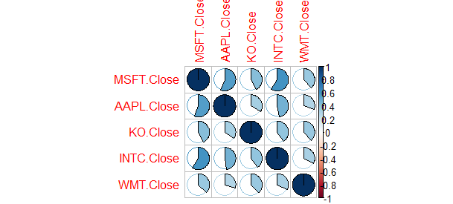

Investing into uncorrelated stocks from different sectors decreases overall risk, although uncorrelated stocks may become correlated due to major macroeconomical factors, which affect industries in general. For a bigger extent adjacent sectors representatives, KO (food) and WFT (retail), may also be affected by sector changes to some extent, while purchasing stocks from the same sector (MSFT, AAPL and INTC ) increases overall risk, because their prices are affected by the same macroeconomical factors and policies thus they tend to rise and fall in concert. The last statement is not obvious, as in oligopoly markets in a same sector prices may not correlate in case if success of one company is justified by the failure of the rest, thus this thesis had to be checked.

Considering correlations, stock variances and individual returns, portfolio variance calculation is suggested. Depending on one’s risk aversion different strategies may be applied. Factors for consideration from the correlation analysis:

-MSFT and INTC show the highest correlation rate and should not be included in a same portfolio unless they provide small volatility and high return comparing to the others (which is the case for MSFT, but not the case for INTC).

-The least correlated are AAPL and WMT (highest expected return, high volatility + moderate expected return, low volatility), AAPL and KO (highest expected return, high volatility + low expected return, low volatility), INTC and WMT (moderate expected return, low volatility both).

1. Monte Carlo Simulation to predict stock price of Microsoft Corp. for the next 4 years.

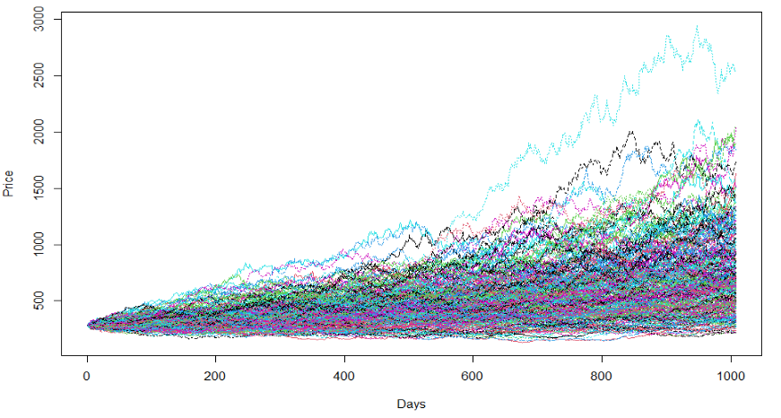

As per the simulation to predict next 4 years stock prices using Monte Carlo simulation for 300 times, below are the observations.

Maximum value it can reach was around $2949.98 which is a very high growth and is more than 10 times of the initial price.

Minimum value as per simulation is #130.33 which is almost half of the initial price.

Mean value is #467.5 which is 60 percent rise on initial price.

Since we have performed simulation 300 times we can make an intuition that the stock price may reach mean value in the span of 4 years as Microsoft stock continues to increase in value.

1. Trading Strategy

We suggest a passive trading strategy (buy and hold) for a 1-year period, after which we review our portfolio results. We pick stocks for our portfolio regarding that we are moderately inclined to take risks. Thus, based on the data frame gathered in task 3 we pick AAPL stocks due to its moderate standard deviation and highest returns among 5 given stocks. To balance our portfolio we also pick a stock with lower deviation and subsequently lower return to decrease the variance of our portfolio. To decrease the overall risk we also pick a stock from a different industry, thus the stocks correlation will be low. WMT has moderate return and low deviation, so it becomes our second choice.

|  |  |  |  |
| --- | --- | --- | --- |
| Percentage of Investment | | | Variances |
| No | Apple | Walmart |
| 1 | 50 | 50 | 0.0002705487 |
| 2 | 25 | 75 | 0.0002158672 |
| 3 | 75 | 25 | 0.0003033575 |
| 4 | 80 | 20 | 0.0003072946 |

To check the proportions for our two-stock portfolio we will make 300 Monte-Carlo simulations with 4 different funds distribution proportions:

In the image below you can see the simulations of the portfolio price movement for 25% AAPL and 75% WMT (#2) and 80% AAPL and 20% WMT (#4). #4 predictably shows higher deviation within a year and provides a higher maximum value. Additionally, #4 also has the highest Sharpe rating among four.

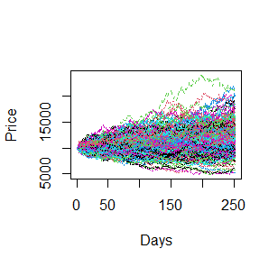

*Portfolio simulation “25% AAPL and 75% WMT” and “80% AAPL and 20% WMT” for 1-year.*

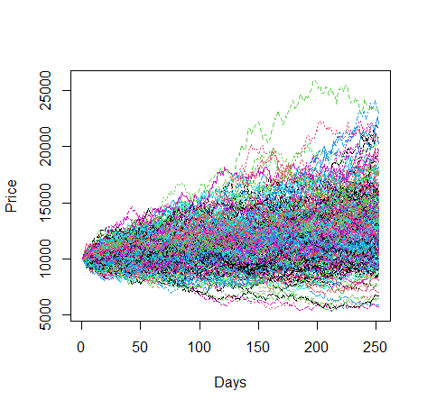

**Alternatively, simulations stock wise:**

-Monte Carlo: (10000 simulations for 80% - 20%)

* Apple Stock price simulation for predicting price after 1 year.
  + Max Price : 507.134
  + Min Price : 59.534
  + Mean Price : 164.383

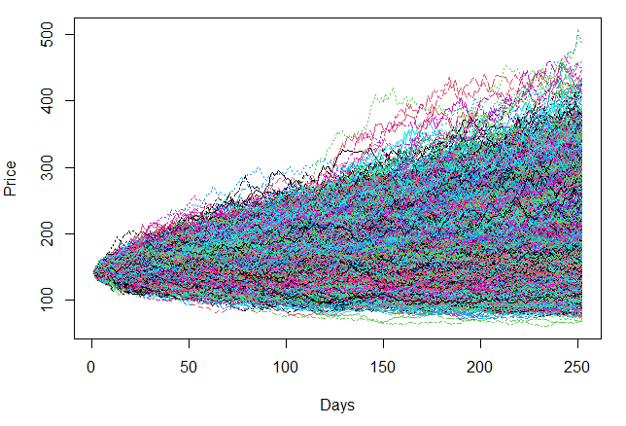

* Walmart Stock price simulation for predicting price after 1 year.
  + Max Price : 300.382
  + Min Price : 72.559
  + Mean Price : 146.849

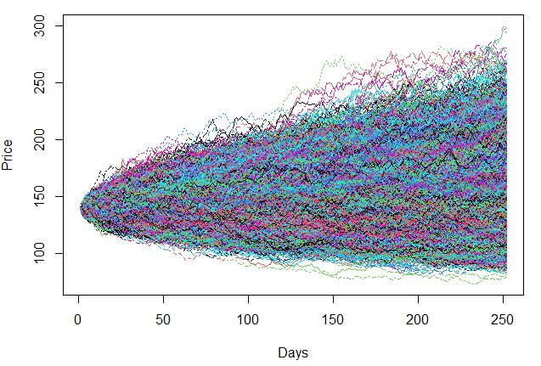

We pick #4. Monte-Carlo simulation showed that investing 10,000 USD with the following proportions: 8000 USD in AAPL and 2000 USD in WMT can provide maximum profit **229.82** % or maximum loss **55.93** %, or an average of **14.01** % growth for entire portfolio.